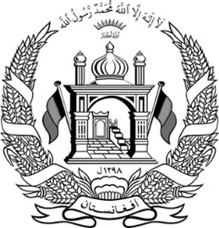

**Islamic Republic of Afghanistan**

**Ministry of Interior Affairs**

**Department of Population Statistics**

Number:

|  |  |  |
| --- | --- | --- |
| **Identification** | | |
| Name |  |  |
| Father’s Name |  |
| Grand Father’s Name |  |
| Place of Birth |  |
| Ethnicity |  |
| Occupation |  |
| Gender |  |
| Marital Status |  |
| Date of Birth |  |
|  | | |
| **Physical Characteristics** | | |
| Height | **Medium** | |
| Color of eye | **Hazel** | |
| Color of skin | **Wheaten** | |
| Color of hair | **Black** | |
| Other sings |  | |
| Fingerprint/signature |  | |
|  | | |
| **Place of Registration** | | |
| Province |  | |
| District |  | |
| Sector |  | |
| Village |  | |
| Street name |  | |
| Home number |  | |
| Volume number |  | |
| Page number |  | |
| Registration number |  | |
| Issue date |  | |
|  | | |
| **ID number of head or member of the family (Father)** | | |
| Volume number |  | |
| Page number |  | |
| Registration number |  | |

Mr/Ms. XXXX, whose identification is written in this national identification document, is a citizen of Afghanistan; so, this ID (Tazkira) is issued to her by the 3rd sector statistics office.

Signature of Registerer Signature of Chief Officer